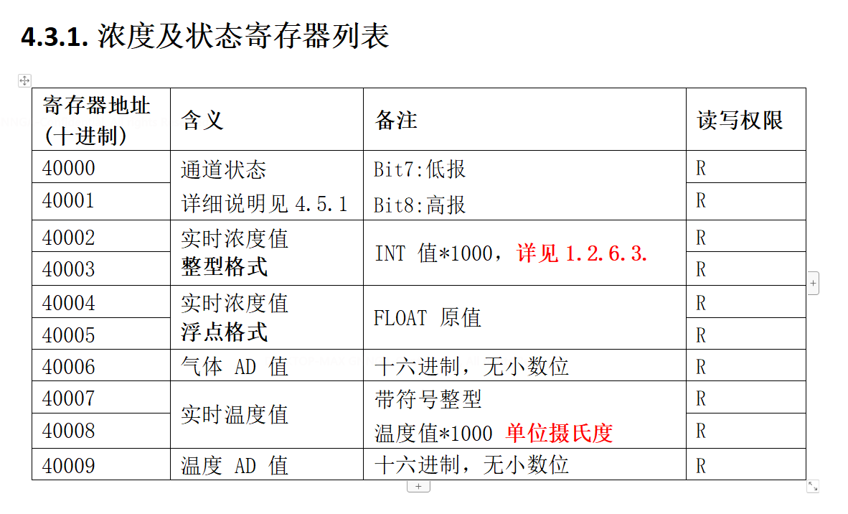
02 03 9C 40 00 0A EA 7A //时间0912测试，读取氨气传感器的浓度命令
01 03 9C 40 00 0A EA 49 //时间0912测试，读取可燃气传感器的浓度命令
Tx:000000-01 03 9C 40 00 0A EA 49
Rx:000001-01 03 14 00 00 00 42 00 00 00 00 00 00 00 00 07 31 00 00 69 78 08 3D 09 62
Tx:000002-01 03 9C 40 00 0A EA 49
Rx:000003-01 03 14 00 00 00 42 00 00 00 00 00 00 00 00 07 31 00 00 69 78 08 3E 49 63
Tx:000004-01 03 9C 40 00 0A EA 49
Rx:000005-01 03 14 00 00 00 42 00 00 00 00 00 00 00 00 07 31 00 00 69 78 08 3F 88 A3
Tx:000006-01 03 9C 40 00 0A EA 49
Rx:000007-01 03 14 00 00 00 42 00 00 00 00 00 00 00 00 07 31 00 00 69 78 08 40 C9 43
Tx:000008-01 03 9C 40 00 0A EA 49
Rx:000009-01 03 14 00 00 00 42 00 00 00 00 00 00 00 00 07 31 00 00 69 78 08 42 48 82

发送报文：
01 通信地址
03 通信功能码 03代表读取
9C 40 读取寄存器地址0x9C40代表40000
00 0A 读取寄存器数量0x0A代表10
EA 49 校验

接收报文：
01 通信地址01
03 回复功能码03
14 回复的字节数0x14代表20
00 00 00 42 通道状态
00 00 00 00 浓度（整型）0
00 00 00 00 浓度（浮点型）0
07 31 AD值1841
00 00 69 78 温度值27℃
08 42 温度AD值2114
48 82 校验

